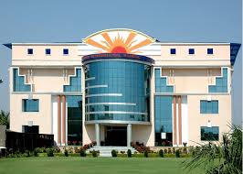

**Sun international school**

**Computer project work**

**Topic - CREATIVE PLANS**

**Submitted to -**

**Nishtha Ma’am**

**Submitted by -**

**Siddhant Nagaria**

**10th - A**

**PREFACE**

With the advancement of technology, rapid globalization, diversified and multifaceted stimulants, children and young people are commonly intelligent and quick-minded.

As a part of the course curriculum and to deepen and widen the practical knowledge in the concept of “HTML”, I have made a project on the same.

Working on this project, I came to know and understand various aspects of the topic “Creative Plans”, at the same time the very importance of creativity and knowledge in student’s life.

I have expressed my experiences in my own simple way. I hope who goes through it will find it interesting and worth reading. All constructive criticism and feedback is cordially invited.

**Siddhant Nagaria**

**10th - A**

**Acknowledgement**

I am very thankful to everyone who all supported me, for I have completed my project effectively and moreover on time. I am overwhelmed in all humbleness and gratefulness to acknowledge my depth to all those who helped me to put these ideas well. I am equally grateful to my computer teacher - Mrs. Nishtha Mam. They gave me moral support and guided me in different matters regarding the topic - “Creative Plans”. With the help of their valuable suggestions, guidance and encouragement, I was able to perform this project work. Last but not the least, I would like to thank my parents who helped me a lot in gathering different information, collecting data and guiding me from time to time. Despite of their busy schedules, they game me their precious time in making this project unique.

**Siddhant Nagaria**

**10th - A**

**Index**

|  |  |  |
| --- | --- | --- |
| S.No. | Topic | Page No. |
| 1. | PREFACE | 2 |
| 2. | ACKNOWLEGEMENT | 3 |
| 3. | INDEX | 4 |
| 4. | INTRODUCTION TO HTML | 5 |
| 5. | CODING | 8 |
| 6. | WEB PAGES | 20 |
| 7. | REFERENCES | 29 |

**Introduction**

**What is HTML ?**

It stands for Hyper Text Markup Language. HTML is a complete code package that allows the user to create web pages. It includes text and graphics. Using HTML, we can add links to web pages.

Hyperlinks are the highlighted text segments or images that connect to other pages on the web. Let us analyze the word HTML.

HYPER TEXT : Hyper Text is the text used to link various web pages. It is the text on the web page, which on clicking opens a new web page.

MARK-UP : It means highlighting the text either by underlining or displaying it in different color, or both.

LANGUAGE : It refers to the way of communication between web pages, which has its own syntax and rules.

**Now, what is a tag ?**

HTML is a **Tag** based language. Tag is an element, which instructs the web browser, what to show and how to show. It shows the structure and appearance of a document or aweb page that is created. The HTML tags or commands are inserted before and after the text written by user to indicate its format and location on the page. We can use various attributes in the tags that contain additional information like formatting effects, alignments, colors, etc. Each tag giving a specific instruction is enclosed in angle brackets <>.

**HTML document structure**

The general structure of an HTML document has two sections : **Head** and **Body**.

**HEAD SECTION** : The Head section contains the Title that identifies the first part of an HTML coded document.

**BODY SECTION** : The body section is where we do most of the work. It includes text, graphics, and other HTML elements that provide control and formatting of a page like : fonts, paragraph, list and other elements. The general format of an HTML document is :

<HTML>

<HEAD>

<TITLE>

Title of the Web page

</TITLE>

</HEAD>

<BODY>

Text, which you want to show on your web page will

Be given here.

</BODY>

</HTML>

**Some Important Tags**

1. HEADING - <H1></H1> to <H6></H6>
2. PARAGRAPH - <P></P>
3. CENTER - <CENYTER></CENTER>
4. FONT - <FONT FACE = “” SIZE = “” COLOR = “”></FONT>
5. BODY - <BODY BGCOLOR = “” ></BODY>
6. BREAK A LINE - <BR></BR>
7. HR - <HR SIZE = “” COLOR = “” WIDTH = “”>
8. UNORDERED LIST - <UL> <LI> </UL>
9. ORDERED LIST - <OL> <LI> </OL>
10. INSERTING A IMAGE - <IMG SRC=”” ALIGN = “”>
11. INTERNAL LINKING - <A HREF=”#LINKNAME”>LINK TO ANOTHER SECTION OF THE SAME DOCUMENT </A>

<A NAME = “LINKNAME”>

1. EXTERNAL LINKING - <A HREF = “LINKNAME”>NAME TO THE LINK </A>
2. ADDING A TABLE - <TABLE> <TR> <TD> </TD> </TR> </TABLE>

**Coding**

1. Creative Plans (Home Page)

<html>

<head>

<title>

CREATIVE PLANS

</title>

</head>

<body bgcolor = "rainbow">

<IMG SRC="[abcd.jpg](view-source:file:///C:/Users/DELL/Desktop/SIDDHANT/CLASS 10/Computer/HTMLs/BOARD 60 MARKS/abcd.jpg)" align =right height = "200" width = "200">

<br><br><br>

<font face = "algerian" size = "8"color = "navy">

<center>

creative plans

</font>

<font face = "times new roman " size = "4">

<marquee>

By:- SIDDHANT NAGARIA <pre>10th A</pre>

</font>

</marquee>

</center>

</font>

<hr size = "7" color = "maroon" width = 70% align = "center">

<br><br>

<font face = "times new roman" size = "6" >

<i><b>

Creative planning is a deliberative technique often embedded within a larger participatory planning process. It's goal is to relieve participants of practical or analytical constraints so that brainstorming and idea generation can flow organically without worrying that one is straying too far 'outside the box'.

</i></b>

</font>

<br><br>

<hr size = "7" color = "maroon" width = 80% align = "center">

<br><br>

<IMG SRC ="[imp.jpg](view-source:file:///C:/Users/DELL/Desktop/SIDDHANT/CLASS 10/Computer/HTMLs/BOARD 60 MARKS/imp.jpg)" align =right height = 250 width = 250>

<font face = "chiller" size = "7">

To be creative, you just need few thing to remember. They are-

<ol type = "123">

<li>Deliberations, Decisions and Public interactions

<li>Influence, Outcomes and Effects

<li>Analysis and Lessons learned

</ol>

</font>

<hr size = "7" color = "maroon" width = 80% align = "center">

<font face = "times new roman" size = "5" >

<p align = "left">

There are many types of Creative Plans. Few of them are given below :-

<ol type = "a">

<li><a href = [adultbased.html](view-source:file:///C:/Users/DELL/Desktop/SIDDHANT/CLASS 10/Computer/HTMLs/BOARD 60 MARKS/adultbased.html)>Adult Based </a>

<li><a href = [childrenbased.html](view-source:file:///C:/Users/DELL/Desktop/SIDDHANT/CLASS 10/Computer/HTMLs/BOARD 60 MARKS/childrenbased.html)>Children Based</a>

</ol>

</font>

<hr size = "7" color = "maroon" width = 80% align = "center">

<font face = "freestyle script" size = "7" >

Just click on the above links to know more. !!!!

</body>

</html>

1. Adult Based Creative Plans (page 2)

<html>

<head>

<title>

Adult Based Creative Plans

</title>

</head>

<body bgcolor = "olive">

<br><br>

<font face = "algerian" size = "7" color = "maroon">

<center>

Adult Based Creative Plans

</font>

<br>

<font face = "calbiri" size = "4">

<marquee>

By:- Siddhant Nagaria <pre>10th A </pre>

</marquee>

</font>

</center>

<hr size = "5" color = "navy" width = 75% align = "center">

<br>

<font face = "freestyle script" size = "8">

<i><b>

<center>

<a href = "[MAIN FILE.html](view-source:file:///C:/Users/DELL/Desktop/SIDDHANT/CLASS 10/Computer/HTMLs/BOARD 60 MARKS/MAIN FILE.html)">Go Back To Home Page</a>

</center>

</i></b>

<hr size = "5" color = "navy" width = 75% align = "center">

<IMG SRC="[AB.png](view-source:file:///C:/Users/DELL/Desktop/SIDDHANT/CLASS 10/Computer/HTMLs/BOARD 60 MARKS/AB.png)" align =right height = 250 width = 250>

<font face = "times new roman" size = "5">

<b><i>

So, I am here to tell you about the different types of creative plans.

<br>

Now, over here , I am going to tell you about Adult Based Creative Plans.

</b></i>

<font face = "calbiri(heading)" size = "5">

<ol type = "a">

<li><a href = "[#Deliberate and Cognitive](view-source:file:///C:/Users/DELL/Desktop/SIDDHANT/CLASS 10/Computer/HTMLs/BOARD 60 MARKS/adultbased.html" \l "Deliberate and Cognitive)">Deliberate and Cognitive</a>

<li><a href = "[#Deliberate and Emotional](view-source:file:///C:/Users/DELL/Desktop/SIDDHANT/CLASS 10/Computer/HTMLs/BOARD 60 MARKS/adultbased.html" \l "Deliberate and Emotional)">Deliberate and Emotional</a>

<li><a href = "[#Spontaneous and Cognitive](view-source:file:///C:/Users/DELL/Desktop/SIDDHANT/CLASS 10/Computer/HTMLs/BOARD 60 MARKS/adultbased.html" \l "Spontaneous and Cognitive)">Spontaneous and Cognitive</a>

</font>

<hr size = "5" color = "navy" width = 75% align = "center">

<font face = "freestyle script" size = "8">

Just click on the above links to know more. !!!!

</font>

<hr size = "5" color = "navy" width = 75% align = "center">

<a name = "Deliberate and Cognitive">

<font face = "Chiller" size = "7">

<b><i><u>

Deliberate and Cognitive

</b></i></u>

</font>

<br><br>

Creative types who are deliberate and cognitively-based are purposeful. They possess a lot of knowledge about a particular subject and combine that with their skills and abilities to put a plan into action. People with this type of creativity are usually adept at research, experimentation and problem-solving. This type of creativity lies in the brain's prefrontal cortex toward the front of the brain.

<br><br>

This quadrant is frequently represented by noted inventor Thomas Edison, who we have to thank for advances in electricity and telecommunications. Edison was noted for the amount of time he spent analyzing his experiments and persevering until he reached his goal.

<br><br><br>

<a name = "Deliberate and Emotional">

<font face = "Chiller" size = "7">

<b><i><u>

Deliberate and Emotional

</b></i></u>

</font>

<br><br>

Creative people who are classified as deliberate and emotional, according to Dietrich, let their work be influenced by their emotions. These are frequently more sensitive and feeling individuals who might prefer lots of quiet time for personal reflection or writing in a diary. But, they are also equally logical and rational, marrying deliberate actions with emotional creativity. This type of creativity lies in the brain's amygdala, responsible for human emotion, and cingulate cortex, which combines learning and information processing.

<br><br>

This quadrant is indicative of those ''A-Ha!'' moments, quick bursts of sudden realization or insight into a problem or idea. An example of this might come following a personal incident like a bankruptcy, where you're reflecting on the decisions that got you to that point and using deliberate and emotional creativity to reflect and overcome your challenge.

<br><br><br>

<a name = "Spontaneous and Cognitive">

<font face = "Chiller" size = "7">

<b><i><u>

Spontaneous and Cognitive

</b></i></u>

</font>

<br><br>

Remember the story of a young Isaac Newton whose ''Eureka!'' moment about the law of gravity came after being hit on the head by a falling apple? This is an example of a spontaneous and cognitive type of creative being. Spontaneous and cognitive creativity appears when individuals have the knowledge necessary to get the job done, but perhaps need inspiration to drop from the sky (a la Newton).

<br><br>

This type of creativity may appear at the most inconvenient time, like coming up with a unique way to finish a story while you're in the shower or envisioning a solution to a problem at work while you're driving on the weekend.

<hr size = "5" color = "navy" width = 75% align = "center">

<font face = "freestyle script" size = "7">

You've all done. Now, you are aware of almost all types of Adult Based Creative Plans.

<br>

Just scroll up to go back to your Home Page. !!!!!

</body>

</html>

1. Children Based Creative Plans(Page 3)

<html>

<head>

<title>

Children Based Creative Plans

</title>

</head>

<body bgcolor = "blue green">

<br><br>

<font face = "algerian" size = "7" color = "aqua">

<center>

<b>

Children Based Creative Plans

</b>

</font>

<font size = "6">

<marquee>

By :- Siddhant Nagaria <pre>10th A </pre>

</marquee>

</center>

<hr size = "5" color = "navy" width = 75% align = "center">

<font face = "freestyle script" size = "8" color = "rainbow">

<center>

<a href = "[MAIN FILE.html](view-source:file:///C:/Users/DELL/Desktop/SIDDHANT/CLASS 10/Computer/HTMLs/BOARD 60 MARKS/MAIN FILE.html)"> Go Back To Home Page </a>

</center>

</font>

<hr size = "5" color = "navy" width = 75% align = "center">

<font face = "freestyle script" size = "7">

<b>

I welcome you again on my webpage to know more about different types of creative plans.

<br>

Over here,I am +++going to tell you all about Children Based Creative Plans. !!!

</b>

</font>

<br>

<ol>

<li><a href = "[Hand Made Crafts.html](view-source:file:///C:/Users/DELL/Desktop/SIDDHANT/CLASS 10/Computer/HTMLs/BOARD 60 MARKS/Hand Made Crafts.html)">Hand Made Crafts</a>

<li><a href = "[Origami.html](view-source:file:///C:/Users/DELL/Desktop/SIDDHANT/CLASS 10/Computer/HTMLs/BOARD 60 MARKS/Origami.html)">Origami</a>

<li><a href = "[Mehndi Design.html](view-source:file:///C:/Users/DELL/Desktop/SIDDHANT/CLASS 10/Computer/HTMLs/BOARD 60 MARKS/Mehndi Design.html)">Mehndi Design</a>

<hr size = "5" color = "navy" width = 75% align = "center">

<font face = "chiller" size = "7">

Just click on the above links to know more. !!!!!

</body>

</html>

3.1 Hand Made Crafts(page 4)

<html>

<head>

<title>

Hand Made Crafts

</title>

</head>

<body bgcolor = "aqua">

<br><br>

<center>

<font face = "algerian" color = "navy" size = "8">

Hand Made Crafts

</font>

<hr size = "6" color = "maroon" width = 75%>

</center>

<font face = "freestyle script" size = "7">

<marquee>

By :- Siddhant Nagaria <pre> 10th A </pre>

</marquee>

<hr size = "6" color = "maroon" width = 75%>

<img src="[hmc.jpg](view-source:file:///C:/Users/DELL/Desktop/SIDDHANT/CLASS 10/Computer/HTMLs/BOARD 60 MARKS/hmc.jpg)" align =right height = 300 width = 300>

<center>

<a href = "[childrenbased.html](view-source:file:///C:/Users/DELL/Desktop/SIDDHANT/CLASS 10/Computer/HTMLs/BOARD 60 MARKS/childrenbased.html)">Go Back To Previous Page. !!!</a>

</center>

</font>

<hr size = "6" color = "maroon" width = 75%>

<br>

<font face = "times new roman" size = "7">

<b><i>

Handicraft

</b></i>

</font>

<br><br>

<font face = "times new roman" size = "5">

A <b>handicraft</b>, sometimes more precisely expressed as <b>artisanal handicraft</b> or <b>handmade</b>, is any of a wide variety of types of work where useful and decorative objects are made completely by hand or by using only simple tools. It is a traditional main sector of craft, and applies to a wide range of creative and design activities that are related to making things with one's hands and skill, including work with textiles, moldable and rigid materials, paper, plant fibers, etc. One of the world's oldest handicraft is Dhokra; this is a sort of metal casting that has been used in India for over 4,000 years and is still used. Usually the term is applied to traditional techniques of creating items (whether for personal use or asproducts) that are both practical and aesthetic.Handicraft industries are those that produces things with hands to meet the needs of the people in their locality.Machines are not used.

<br>

Collective terms for handicrafts include <b>artisanry</b>, <b>handicrafting</b>, <b>crafting</b>, and <b>handicraftsmanship</b>.

<br>

The term <b>arts and crafts</b> is also applied, especially in the United States and mostly to hobbyists' and children's output rather than items crafted for daily use, but this distinction is not formal, and the term is easily confused with the Arts and Crafts design movement, which is in fact as practical as it is aesthetic.

<br>

Handicrafting has its roots in the rural crafts —the material-goods necessities—of ancient civilizations, and many specific crafts have been practiced for centuries, while others are modern inventions, or popularizations of crafts which were originally practiced in a limited geographic area.

</p>

<p>

Many handicrafters use natural, even entirely indigenous, materials while others may prefer modern, non-traditional materials, and even upcycle industrial materials. The individual artisanship of a handicrafted item is the paramount criterion; those made by mass production or machines are not handicraft goods.

</p>

<p>

Seen as developing the skills and creative interests of students, generally and sometimes towards a particular craft or trade, handicrafts are often integrated into educational systems, both informally and formally. Most crafts require the development of skill and the application of patience, but can be learned by virtually anyone.

</p>

<p>

Like folk art, handicraft output often has cultural and/or religious significance, and increasingly may have a political message as well, as in craftivism. Many crafts become very popular for brief periods of time (a few months, or a few years), spreading rapidly among the crafting population as everyone emulates the first examples, then their popularity wanes until a later resurgence.

</p>

<h2>Contents</h2>

<ul>

<li><a href = "[#The Art and Crafts movements in the World](view-source:file:///C:/Users/DELL/Desktop/SIDDHANT/CLASS 10/Computer/HTMLs/BOARD 60 MARKS/Hand Made Crafts.html" \l "The Art and Crafts movements in the World)">The Art and Crafts movements in the World</a>

<li><a href = "[#In Modern Education](view-source:file:///C:/Users/DELL/Desktop/SIDDHANT/CLASS 10/Computer/HTMLs/BOARD 60 MARKS/Hand Made Crafts.html" \l "In Modern Education)">In Modern Education</a>

<li><a href = "[#List of Common Handicrafts](view-source:file:///C:/Users/DELL/Desktop/SIDDHANT/CLASS 10/Computer/HTMLs/BOARD 60 MARKS/Hand Made Crafts.html" \l "List of Common Handicrafts)">List of Common Handicrafts</a>

<ul><li><a href = "[#Using textiles or leather](view-source:file:///C:/Users/DELL/Desktop/SIDDHANT/CLASS 10/Computer/HTMLs/BOARD 60 MARKS/Hand Made Crafts.html" \l "Using textiles or leather)">Using textiles or leather</a>

<li><a href = "[#Using wood, metal, clay, bone, horn, glass, or stone](view-source:file:///C:/Users/DELL/Desktop/SIDDHANT/CLASS 10/Computer/HTMLs/BOARD 60 MARKS/Hand Made Crafts.html" \l "Using wood, metal, clay, bone, horn, glass, or stone)">Using wood, metal, clay, bone, horn, glass, or stone</a>

<li><a href = "[#Using paper or canvas](view-source:file:///C:/Users/DELL/Desktop/SIDDHANT/CLASS 10/Computer/HTMLs/BOARD 60 MARKS/Hand Made Crafts.html" \l "Using paper or canvas)">Using paper or canvas</a>

<li><a href = "[#Using plants other than wood](view-source:file:///C:/Users/DELL/Desktop/SIDDHANT/CLASS 10/Computer/HTMLs/BOARD 60 MARKS/Hand Made Crafts.html" \l "Using plants other than wood)">Using plants other than wood</a>

<li><a href = "[#Other](view-source:file:///C:/Users/DELL/Desktop/SIDDHANT/CLASS 10/Computer/HTMLs/BOARD 60 MARKS/Hand Made Crafts.html" \l "Other)">Other</a>

</ul>

<li><a href = "[#Sales Venues](view-source:file:///C:/Users/DELL/Desktop/SIDDHANT/CLASS 10/Computer/HTMLs/BOARD 60 MARKS/Hand Made Crafts.html" \l "Sales Venues)">Sales Venues</a>

</ul>

<hr size = "6" color = "maroon" width = 70%>

<br>

<font face = "chiller" size = "8">

<a name = "The Art and Crafts movements in the World">

<b>

The Art and Crafts movements in the World

</b>

</font>

<br>

The Arts and Crafts movement originated as a late 19th-century design reform and social movement principally in Europe, North America and Australia, and continues today. Its proponents are motivated by the ideals of movement founders such as William Morris and John Ruskin, who proposed that in pre-industrial societies, such as the European Middle Ages, people had achieved fulfillment through the creative process of handicrafts. This was held up in contrast to what was perceived to be the alienating effects of industrial labor.Works Progress Administration, Crafts Class, 1935.

<br>

These activities were called crafts because originally many of them were professions under the guild system. Adolescents were apprenticed to a master craftsman, and refined their skills over a period of years in exchange for low wages. By the time their training was complete, they were well equipped to set up in trade for themselves, earning their living with the skill that could be traded directly within the community, often for goods and services. The Industrial Revolution and the increasing mechanization of production processes gradually reduced or eliminated many of the roles professional craftspeople played, and today many handicrafts are increasingly seen, especially when no longer the mainstay of a formal vocational trade, as a form of hobby, folk art and sometimes even fine art.

<br><br>

<a name = "In Modern Education">

<font face = "chiller" size = "8">

<b>In Modern Education</b>

</font>

<br>

Simple "arts and crafts" projects are a common elementary and middle school activity in both mainstream and alternative education systems around the world.

<br>

In some of the Scandinavian countries, more advanced handicrafts form part of the formal, compulsory school curriculum, and are collectively referred to as slöjd in Swedish, and käsityö or veisto in Finnish. Students learn how to work with mainly metal, textile and wood, not for professional training purposes as in American vocational–technical schools, but with the aim to develop children's and teens' practical skills, such as everyday problem-solving ability, tool use, and understanding of the materials that surround us for economical, cultural and environmental purposes.

<br>

Secondary schools and college and university art departments increasingly provide elective options for more handicraft-based arts, in addition to formal "fine arts", a distinction that continues to fade throughout the years, especially with the rise of studio craft, i.e. the use of traditional handicrafting techniques by professional fine artists.

<br>

Many community centers and schools run evening or day classes and workshops, for adults and children, offering to teach basic craft skills in a short period of time.

<br><br>

<a name = "List of Common Handicrafts">

<font face = "chiller" size = "8">

<b>List of Common Handicrafts</b>

</font>

<IMG SRC="[xy.jpg](view-source:file:///C:/Users/DELL/Desktop/SIDDHANT/CLASS 10/Computer/HTMLs/BOARD 60 MARKS/xy.jpg)" align =right height = 200 width = 200>

<br>

There are almost as many variations on the theme of handicrafts as there are crafters with time on their hands, but they can be broken down into a number of categories:

<br><br>

<a name = "Using textiles or leather">

<b>Using textiles or leather </b>

<IMG SRC="[cal.png](view-source:file:///C:/Users/DELL/Desktop/SIDDHANT/CLASS 10/Computer/HTMLs/BOARD 60 MARKS/cal.png)" align =right height = 200 width = 200>

<ol type = "I">

<li>bagh prints

<li>canvas work

<li>banner making

<li>cross stitch

<li>calligraphy

<li>crochet,etc.

</ol>

<a name = "Using wood, metal, clay, bone, horn, glass, or stone">

<b>Using wood, metal, clay, bone, horn, glass, or stone</b>

<IMG SRC="[bead.jpg](view-source:file:///C:/Users/DELL/Desktop/SIDDHANT/CLASS 10/Computer/HTMLs/BOARD 60 MARKS/bead.jpg)" align =right height =200 width = 200>

<ol type = "I">

<li>bead work

<li>ceramic art

<li>carpentary

<li>fretwork

<li>glassblowing

<li>marquetry

</ol>

<a name = "Using paper or canvas">

<b>Using paper or canvas</b>

<img src="[assem.jpg](view-source:file:///C:/Users/DELL/Desktop/SIDDHANT/CLASS 10/Computer/HTMLs/BOARD 60 MARKS/assem.jpg)" align =right height = 200 width = 200>

<ol type = "I">

<li>Altered books

<li>assemblage

<li>paper craft(generally)

<li>paper marbling

<li>scrapbooking

<li>rubber/arcylic stamping

</ol>

<a name = "Using plants other than wood">

<b>Using plants other than wood</b>

<img src="[bask.jpg](view-source:file:///C:/Users/DELL/Desktop/SIDDHANT/CLASS 10/Computer/HTMLs/BOARD 60 MARKS/bask.jpg)" align =right height = 200 width = 200>

<ol type = "I">

<li>basket weaving

<li>corn dolly making

<li>floral design

<li>pressed flower craft

<li>straw marquetry

</ol>

<a name = "Other">

<b>Other</b>

<img src="[cake.gif](view-source:file:///C:/Users/DELL/Desktop/SIDDHANT/CLASS 10/Computer/HTMLs/BOARD 60 MARKS/cake.gif)" align =right height = 200 width = 200>

<ol type = "I">

<li>Balloon animals

<li>cake decorating

<li>egg decorating

</OL>

<a name = "Sales Venues">

<font face = "chiller" size = "7">

<b>Sales Venues</b>

</font>

<br>

<img src="[sap.jpg](view-source:file:///C:/Users/DELL/Desktop/SIDDHANT/CLASS 10/Computer/HTMLs/BOARD 60 MARKS/sap.jpg)" align =right height = 200 width =200>

Handicrafts are often made for home use.If sold, they are sold in direct sales, gift shops, public markets, and online shopping. In developing countries, handicrafts are sold to locals and as souvenirs to tourists. Sellers tend to speak at least a few words of common tourist languages. There are also specialty markets such as:

<ul>

<li>

Pike Place Public Market of Seattle

<li>

Street Artists Program of San Francisco

<li>Ann Arbor Art Fairs

<li>International Art and Craft Fair, Ouagadougou

</ul>

<br>

<hr size = "6" color = "maroon" width = 70%>

<br>

<font face = "freestyle script" size = "8">

Just scroll up to back to previous page. !!!!

</body>

</html>

* 1. **Origami (Page 5)**

<html>

<head>

<title>

Origami

</title>

</head>

<body bgcolor = "orange">

<font face = "algerian" color = "navy" size = "7">

<center>

Origami

</center>

</font>

<hr size = "6" color = "maroon" width = 70% align = "center">

<font size = "6">

<marquee>

<pre>

<b>By:- Siddhant Nagaria10th A

</b></pre></marquee>

<hr size = "6" color = "maroon" width = 70% align = "center">

<center>

<font face = "freestyle script" size = "7">

<a href = "[childrenbased.html](view-source:file:///C:/Users/DELL/Desktop/SIDDHANT/CLASS 10/Computer/HTMLs/BOARD 60 MARKS/childrenbased.html)">Go Back To Previous Page</a>

</font>

</center>

<hr size = "6" color = "maroon" width = 70% align = "center">

<img src="[pqr.jpg](view-source:file:///C:/Users/DELL/Desktop/SIDDHANT/CLASS 10/Computer/HTMLs/BOARD 60 MARKS/pqr.jpg)" align =right height = 200 width = 200>

<font face = "chiller">

<b><i><h1>ORIGAMI</h1></b></i>

</font>

Origami (ori meaning "folding", and kami meaning "paper" (kami changes to gami due to rendaku)) is the art of paper folding, which is often associated with Japanese culture. In modern usage, the word "origami" is used as an inclusive term for all folding practices, regardless of their culture of origin. The goal is to transform a flat square sheet of paper into a finished sculpture through folding and sculpting techniques. Modern origami practitioners generally discourage the use of cuts, glue, or markings on the paper. Origami folders often use the Japanese word kirigami to refer to designs which use cuts, although cutting is more characteristic of Chinese papercrafts.

<br><br>

</body>

</html>

* 1. **Mehndi Design (page6)**

<html>

<head>

<title>

Mehandi Design

</title>

</head>

<body bgcolor = "rainbow">

<font face = "algerian" size = "7" color = "navy">

<center>

Mehndi Design

</center>

</font>

<hr size = "6" color = "maroon" width = 70% align = "center">

<marquee>

<pre>

<font face = "freestyle script" size = "6">

By:- Siddhant Nagaria

10th A

</pre>

</marquee>

<hr size = "6" color = "maroon" width = 70% align = "center">

<font face = "chiller" size = "7">

<center>

<a href = "[childrenbased.html](view-source:file:///C:/Users/DELL/Desktop/SIDDHANT/CLASS 10/Computer/HTMLs/BOARD 60 MARKS/childrenbased.html)">Go Back To Previous Page</a>

</center>

<hr size = "6" color = "maroon" width = 70% align = "center">

</font>

<img src="[xyz.jpg](view-source:file:///C:/Users/DELL/Desktop/SIDDHANT/CLASS 10/Computer/HTMLs/BOARD 60 MARKS/xyz.jpg)" align =left height = 200 width = 200>

<img src="[qwert.jpg](view-source:file:///C:/Users/DELL/Desktop/SIDDHANT/CLASS 10/Computer/HTMLs/BOARD 60 MARKS/qwert.jpg)" align =right height = 200 width = 200>

<font face = "freestyle script" size = "8">

<b>Mehndi Design</b>

</font>

<br>

<font size = "5">

Mehndi, mehendi or henna is a form of body art from India, Pakistan, Arabia and the Arab world in which decorative designs are created on a person's body, using a paste, created from the powdered dry leaves of the henna plant (Lawsonia inermis). Ancient in origin, mehndi is still a popular form of body art among the women of the Indian Subcontinent, Africa and the Middle East.

<br>

Mehndi is derived from the Sanskrit word mendhika. The use of mehndi and turmeric is described in the earliest Hindu Vedic ritual books. It was originally used for only women's palms and sometimes for men, but as time progressed, it was more common for men to wear it. Haldi (staining oneself with turmeric paste) as well as mehndi are Vedic customs, intended to be a symbolic representation of the outer and the inner sun. Vedic customs are centered on the idea of "awakening the inner light". Traditional Indian designs are representations of the sun on the palm, which, in this context, is intended to represent the hands and feet. Mehendi has a great significance in performing classical dance like bharatnatyam.

<br>

</body>

</hml>

**Web pages**

P.T.O.

WEB PAGE OF CREATIVE PLANS (HOME PAGE)

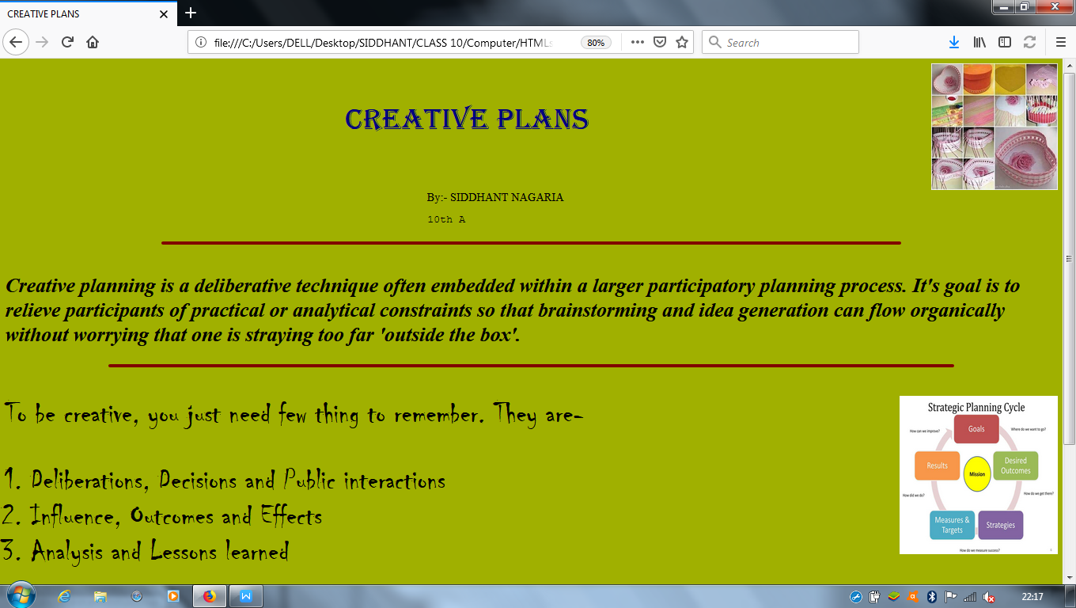

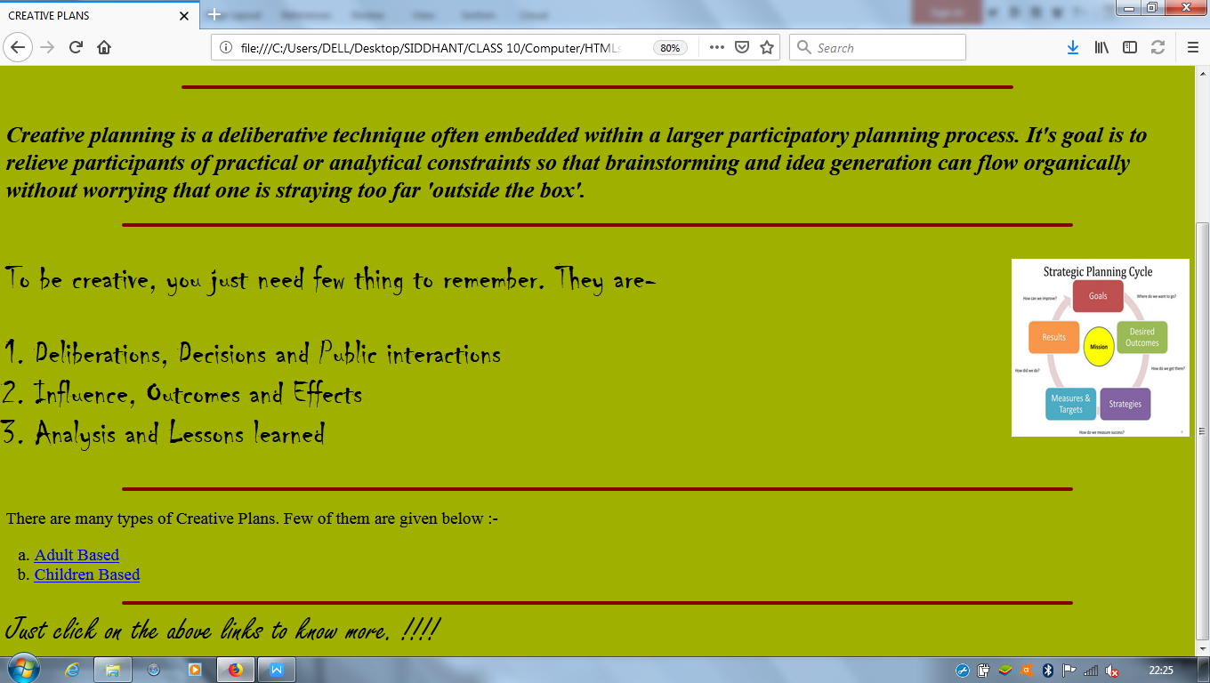

WEB PAGE OF ADULT BASED CREATIVE PLANS (page 2)

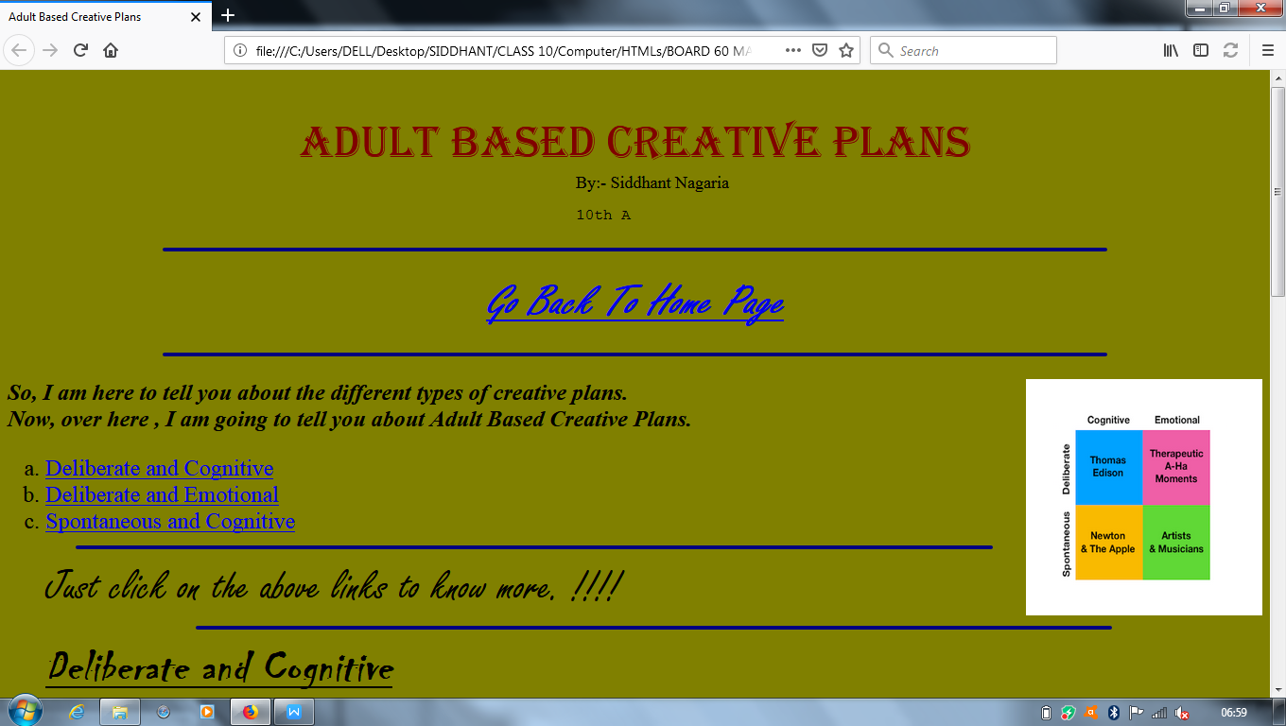

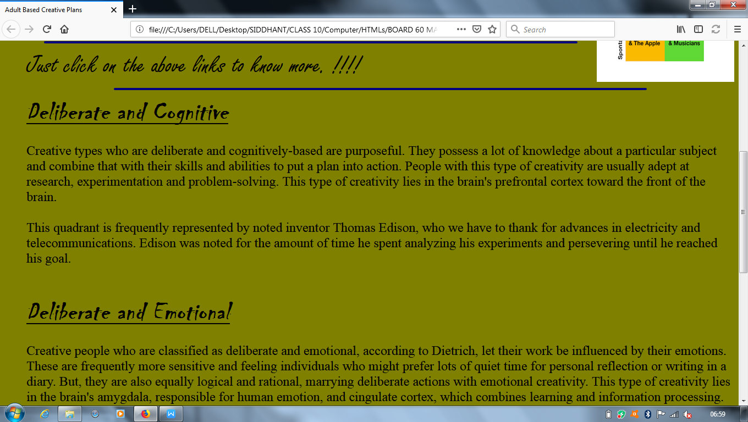

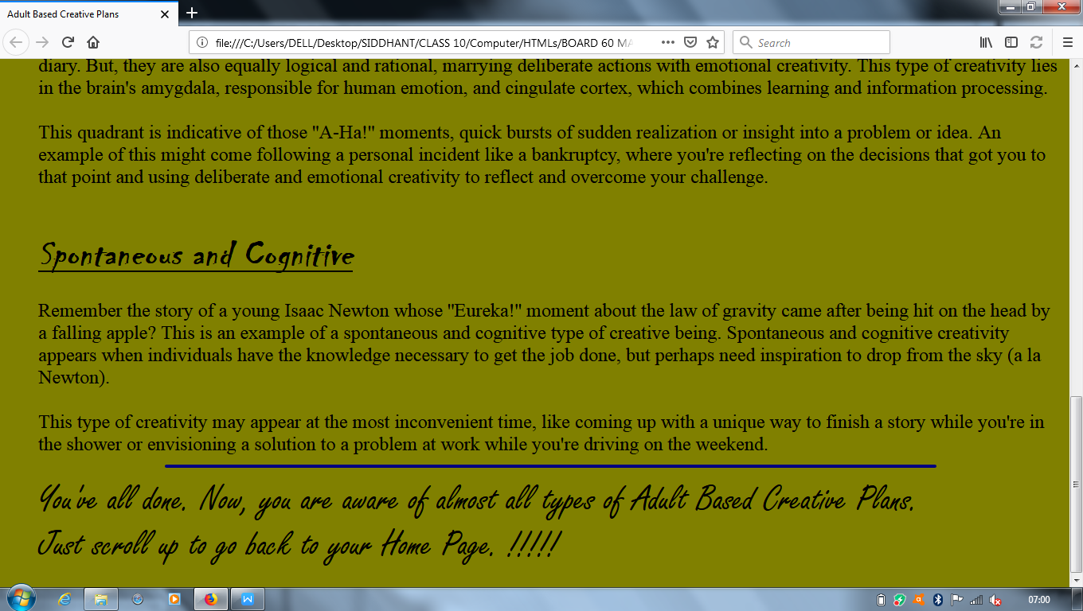

WEB PAGE OF CHILDREN BASED CREATIVE PLANS (PAGE 3)

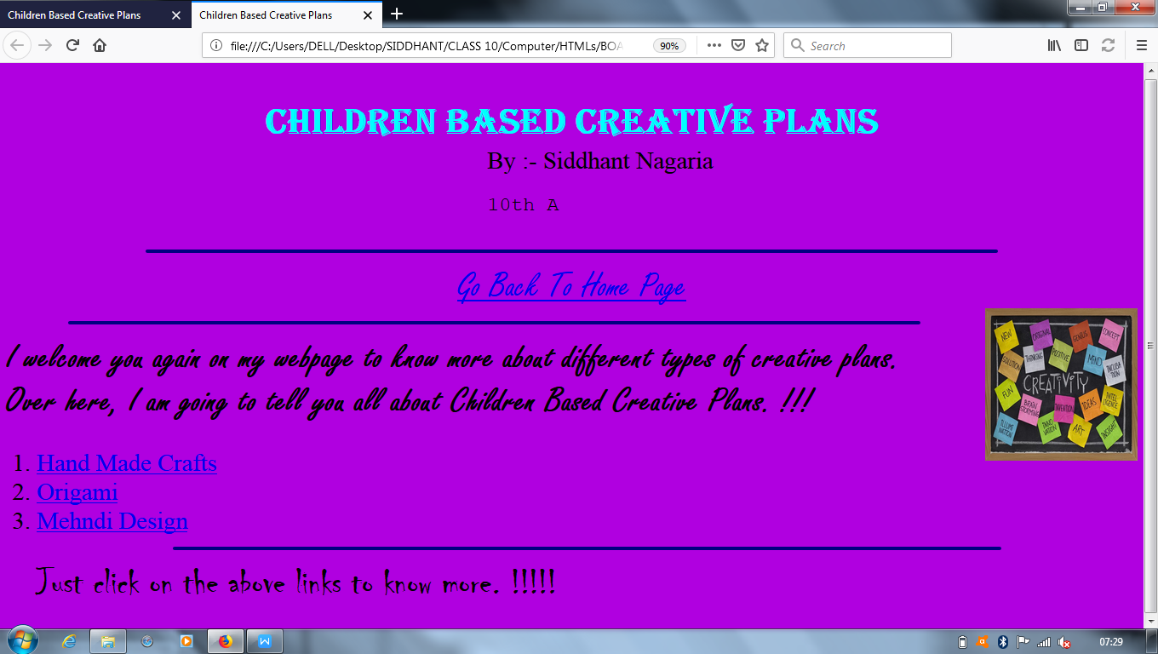

WEBPAGE OF HAND MADE CRAFTS (PAGE 4)

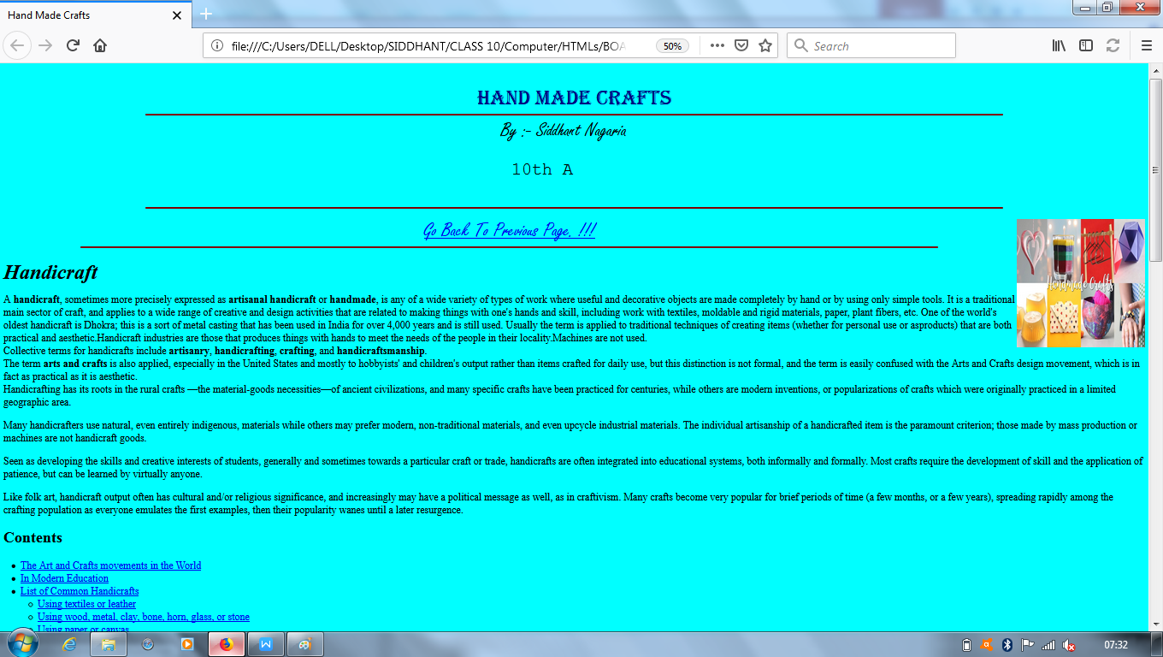

HAND MADE CRAFTS (PAGE 4 CONTINUED)

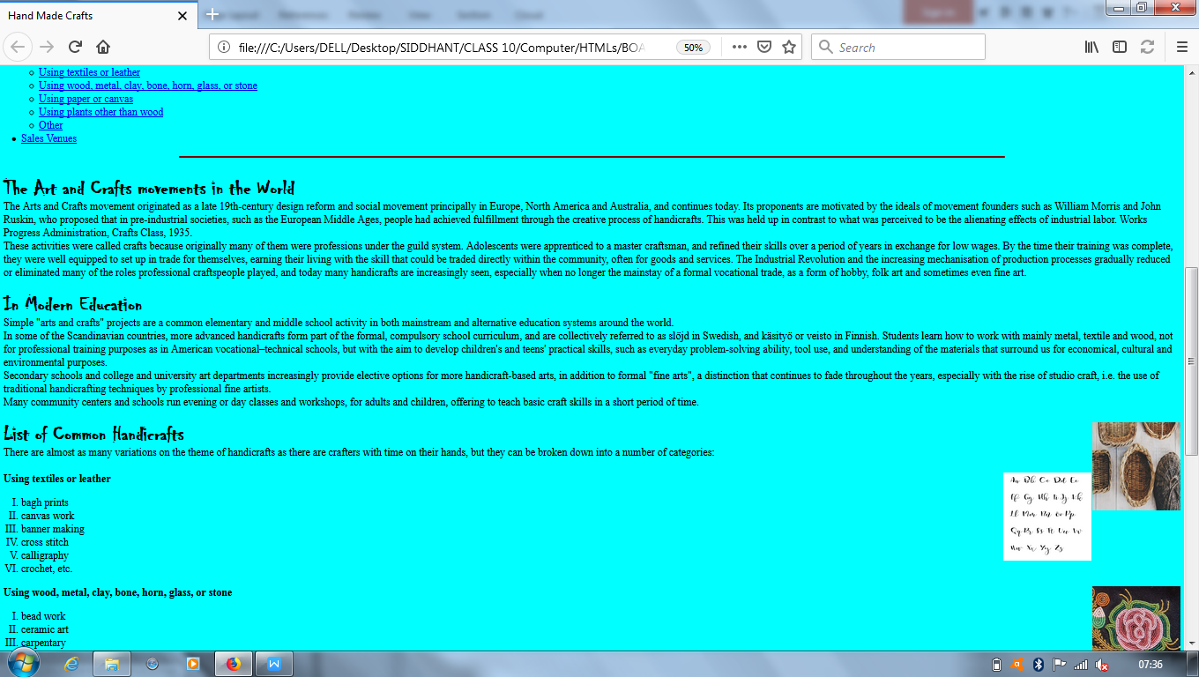

PAGE 4 CONTINUED

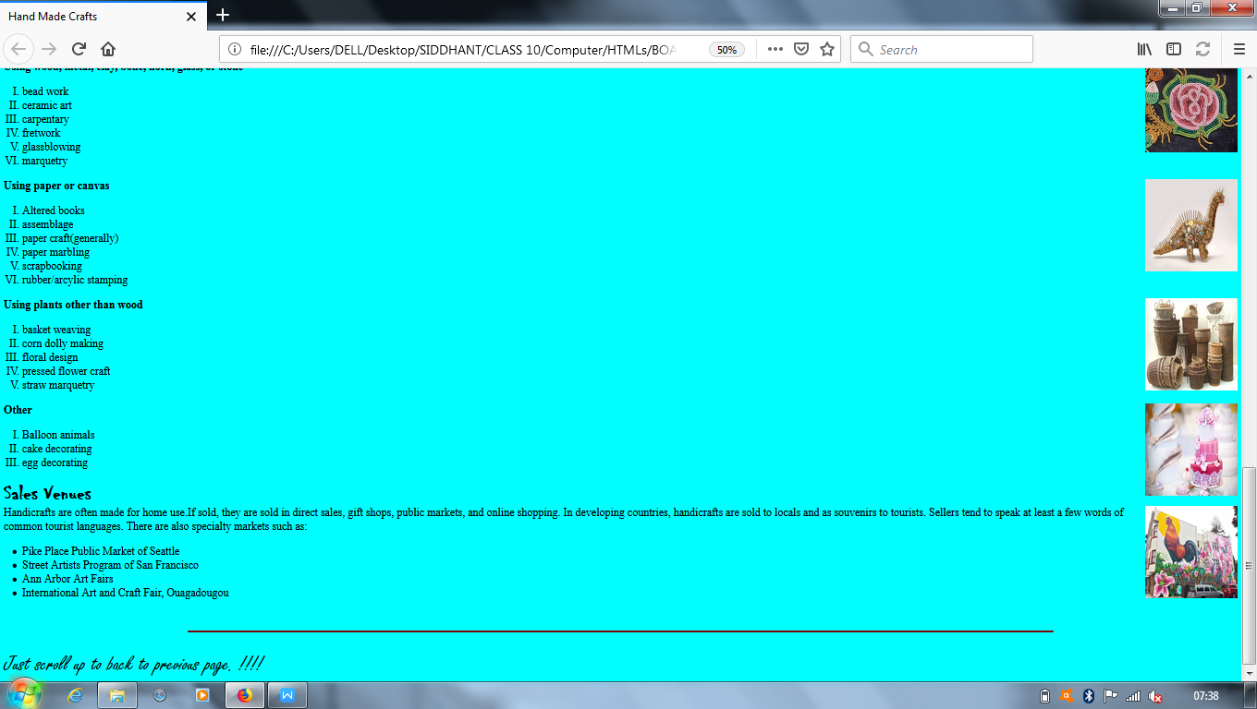

WEBPAGE OF ORIGAMI (PAGE 5)

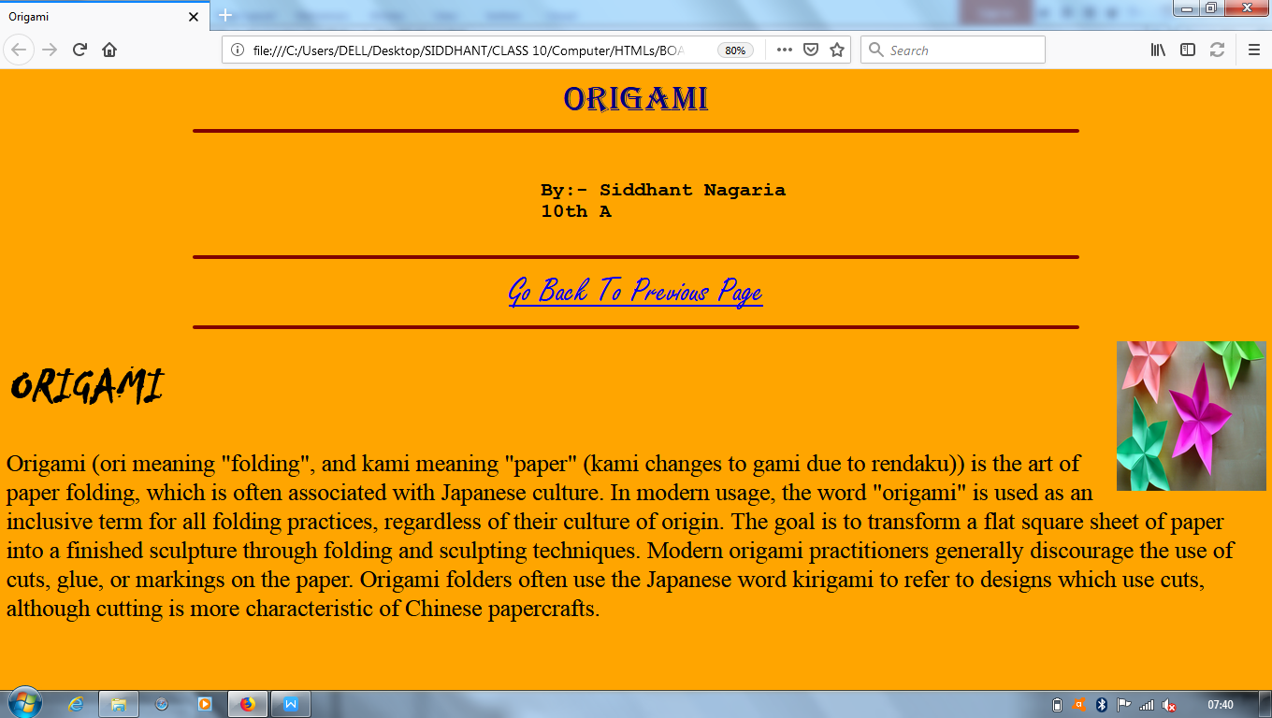

WEB PAGE OF MEHNDI DESIGN (PAGE 6)

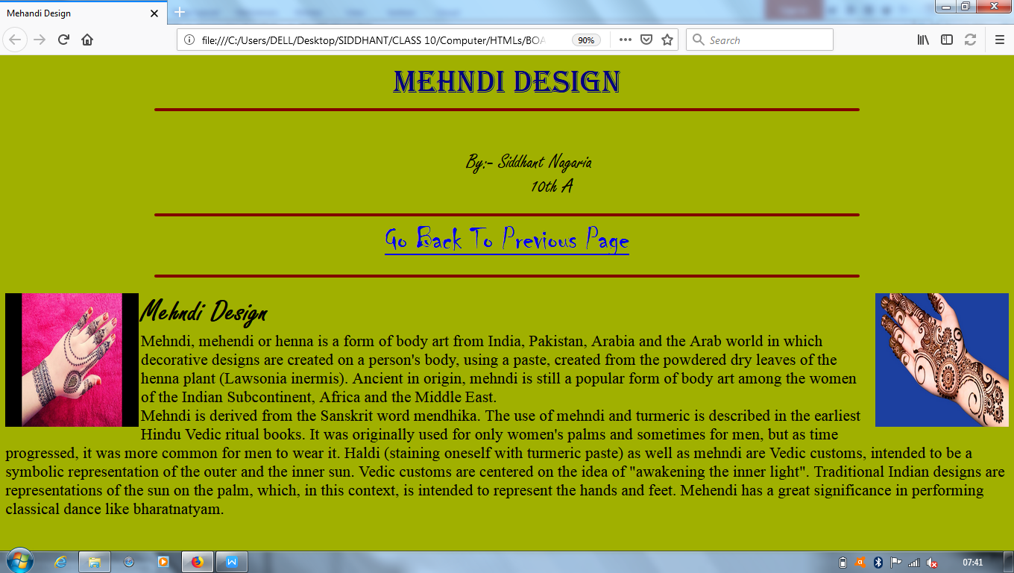

**REFERENCES**

1. **[GOOGLE](http://www.gogle.com)**
2. **[WIKIPEDIA](http://www.wikipedia.org/)**
3. **[STUDY.COM](http://www.study.com)**